Product Inventory Management System
Backend Project Documentation (Node.js | Express.js | MongoDB)

Team ID : SWTID-2026-9130
Team Leader : MADHAVAN R — Project Manager
Team Member : LINGESH S T — Authentication Developer
Team Member : LOGESWARAN P — Database Developer
Team Member : MOHAMMED ABIJEETH M I — API Developer
Team Member : MOHAMMED SAMEER N — Middleware & Deployment

Abstract
The Product Inventory Management System is a backend web application developed using Node.js, Express.js, and MongoDB to efficiently manage product inventory data. The system provides secure user authentication using JSON Web Tokens (JWT), allowing users to register and log in safely. Once authenticated, users can perform CRUD operations such as adding, viewing, updating, and deleting products through RESTful APIs.
The application ensures that each user can access and manage only their own product records, improving data security and privacy. MongoDB is used as the database with Mongoose for efficient data handling. This project demonstrates the implementation of a scalable backend architecture with proper authentication, API structure, and database management for effective inventory control.

1. Introduction
The Product Inventory Management System is a backend web application built using Node.js, Express.js, and MongoDB.
It allows users to register, log in securely using JWT authentication, and manage their product inventory.
The system provides RESTful APIs for creating, viewing, updating, and deleting product records while ensuring
that users can access only their own data.

2. Objectives
• Implement secure user authentication using JWT.
• Provide CRUD operations for product inventory management.
• Ensure user-specific data access.
• Build a scalable backend architecture using Node.js and Express.
• Handle API requests with proper validation and error handling.

3. Core Features
• User Authentication (Register/Login using JWT)
• Product CRUD Operations
• Secure API Access using Middleware
• User-specific product management
• Product search functionality

4. Technologies Used
• Node.js – Backend runtime environment
• Express.js – Web application framework
• MongoDB – NoSQL database
• Mongoose – ODM for MongoDB
• JWT – Authentication
• bcryptjs – Password hashing
• dotenv – Environment variable management

5. Project Folder Structure
server/
├── src/
│ ├── controllers/
│ ├── db/
│ ├── middlewares/
│ ├── models/
│ ├── routes/
│ └── server.js
├── .env
├── package.json
└── package-lock.json

6. Installation Steps
1. Install project dependencies
npm install

2. Run the development server
npm run dev

7. Environment Configuration
Create a .env file and add:

PORT=5000
MONGO_URI=your_mongodb_connection_string
JWT_SECRET=your_secret_key

8. Database Design
Users Collection:
• name
• email
• password

Products Collection:
• userId
• name
• price
• quantity
• description

Relationship: One User can have multiple Products.

9. Output
- Server Running (VS Code):
Shows Node.js server running and MongoDB connected.
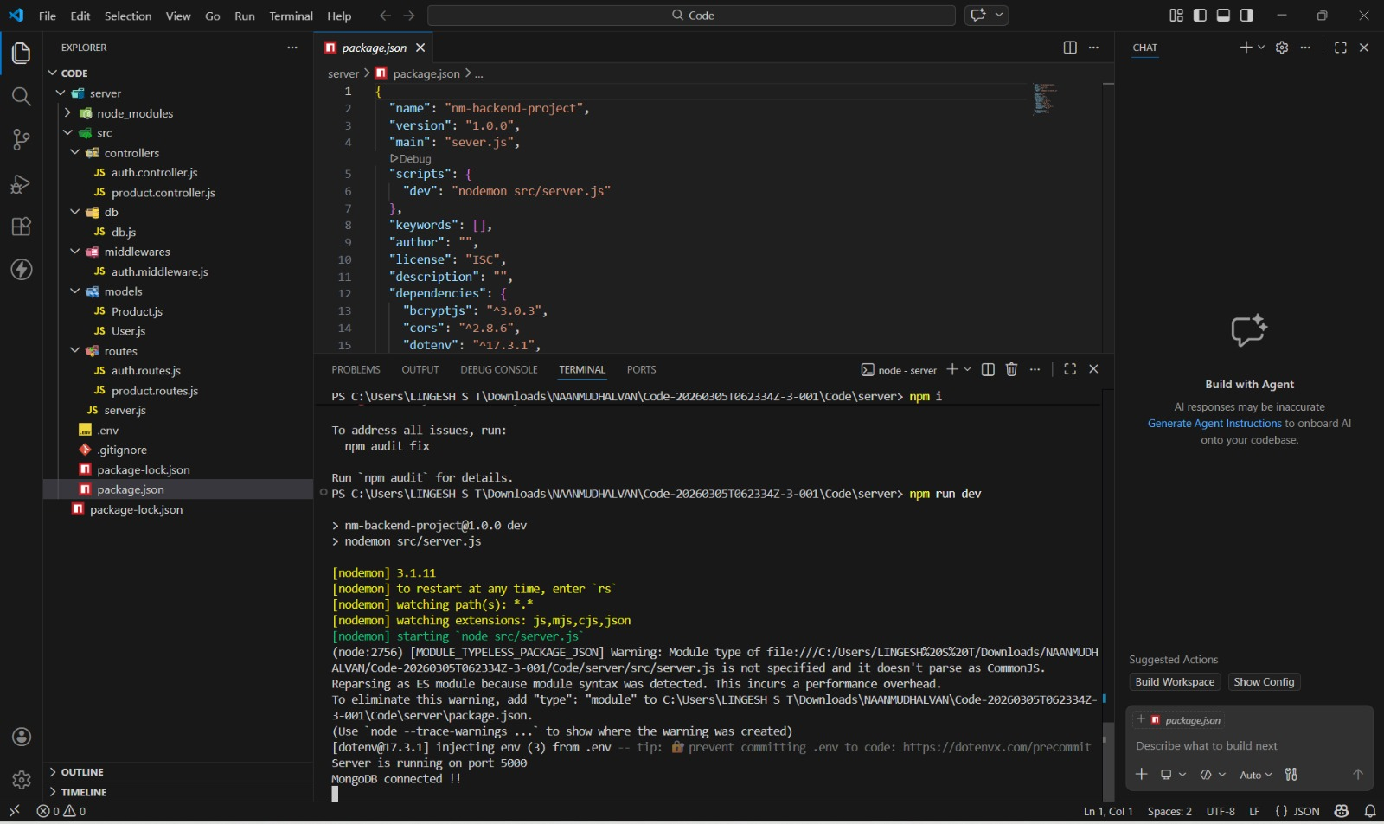
- User Registration:
Shows successful user registration and JWT token generation.
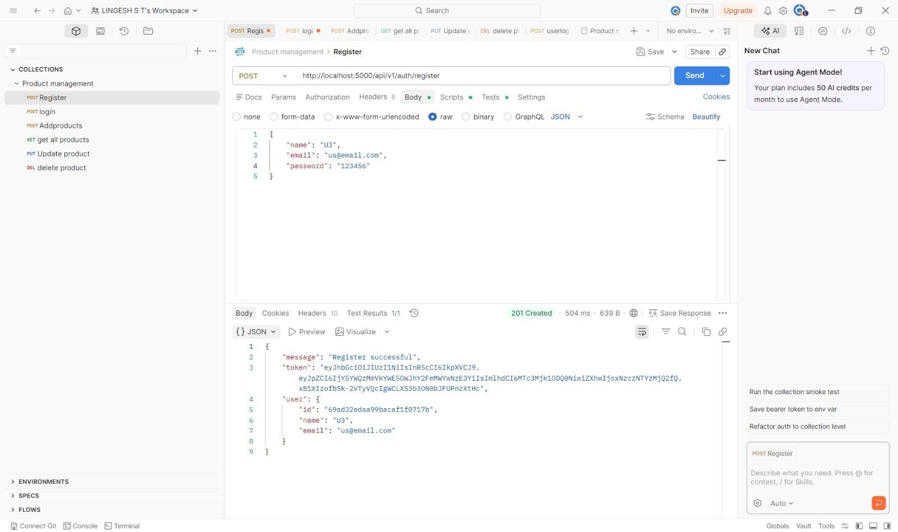

- User Login:
Displays successful user login and authentication token.
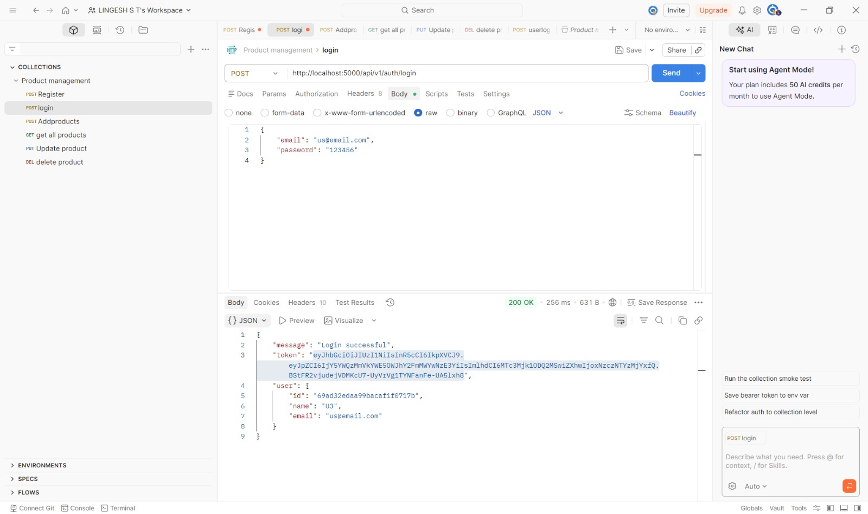
- Add Product:
Shows creation of a new product in the database.
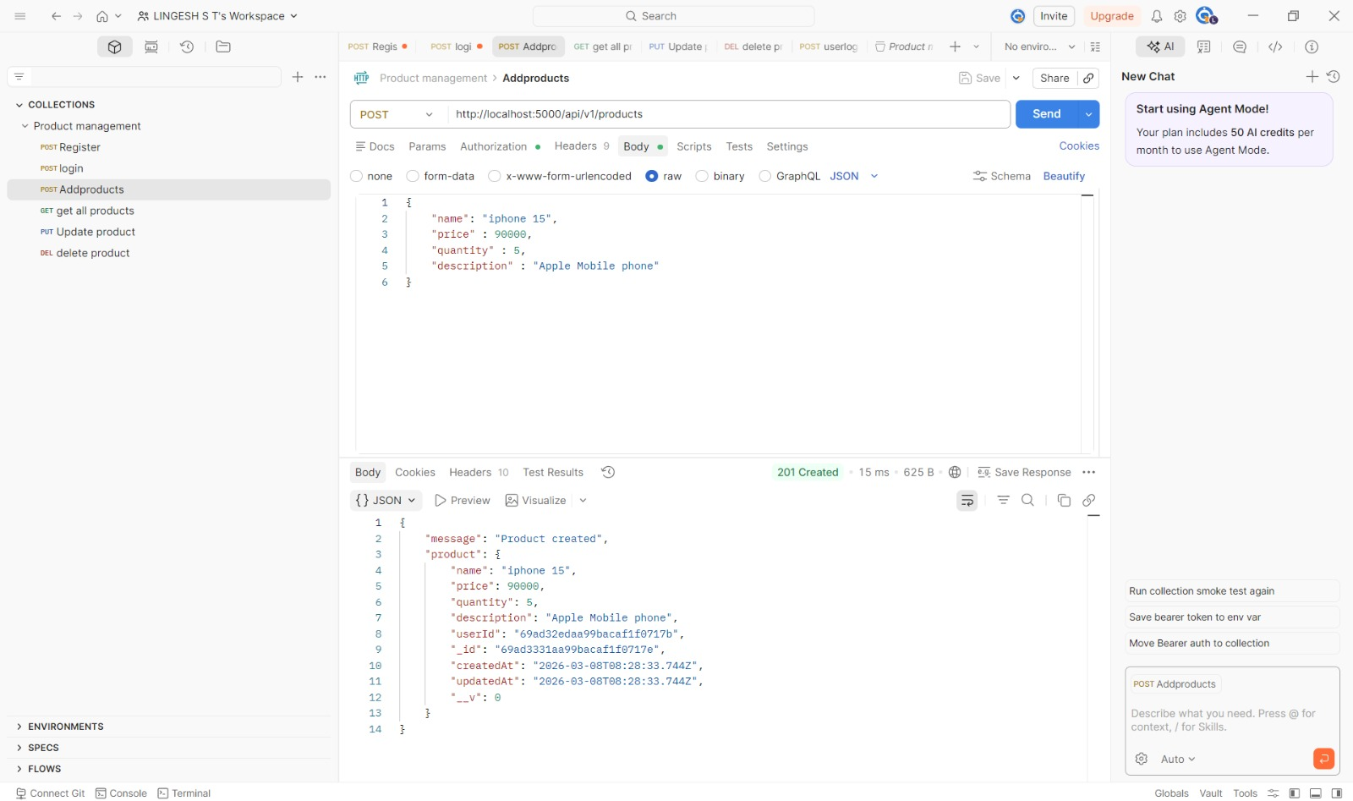
- Get All Products:
Displays the list of products stored in the database.
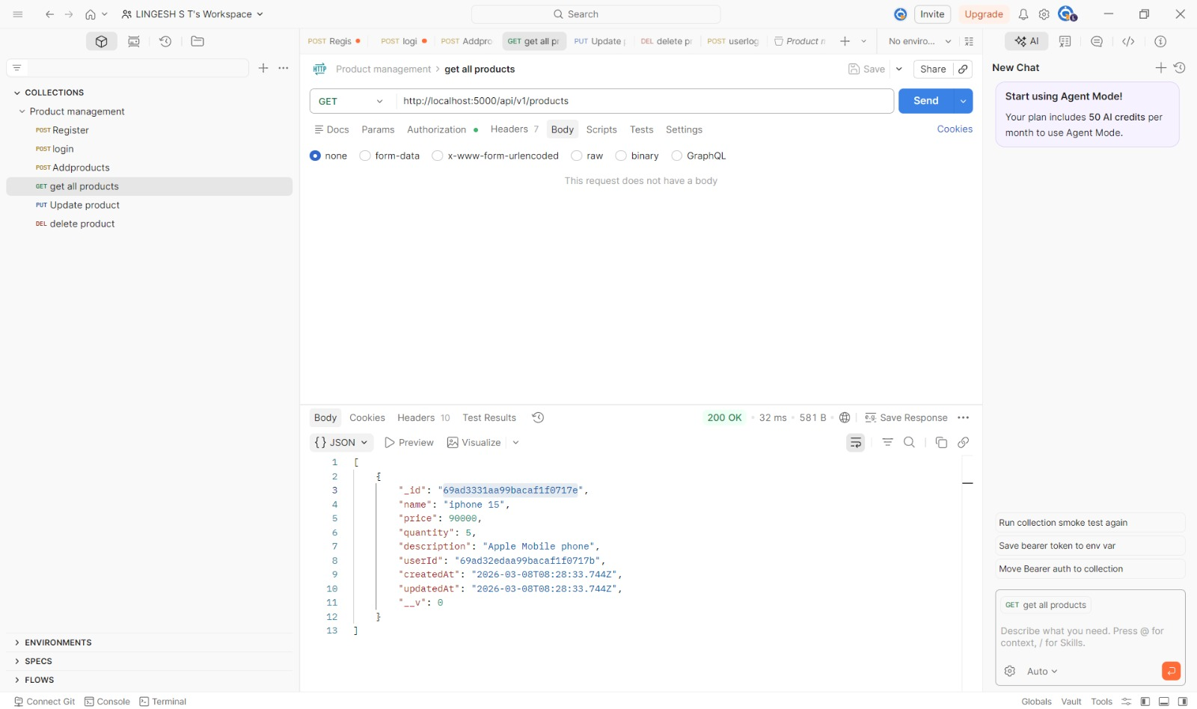
- Update Product:
Product details updated successfully.
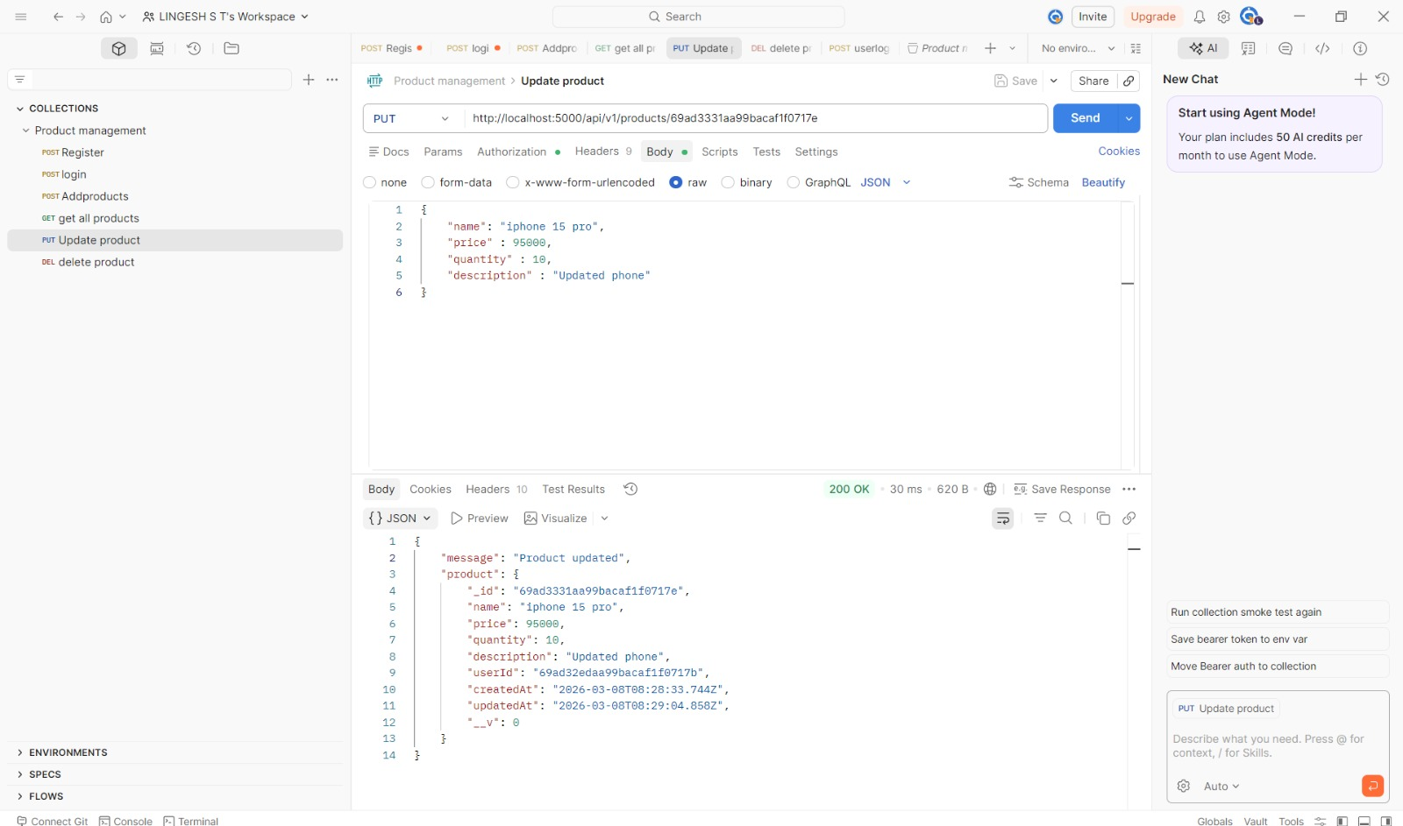

- Delete Product:
Shows successful deletion of a product.
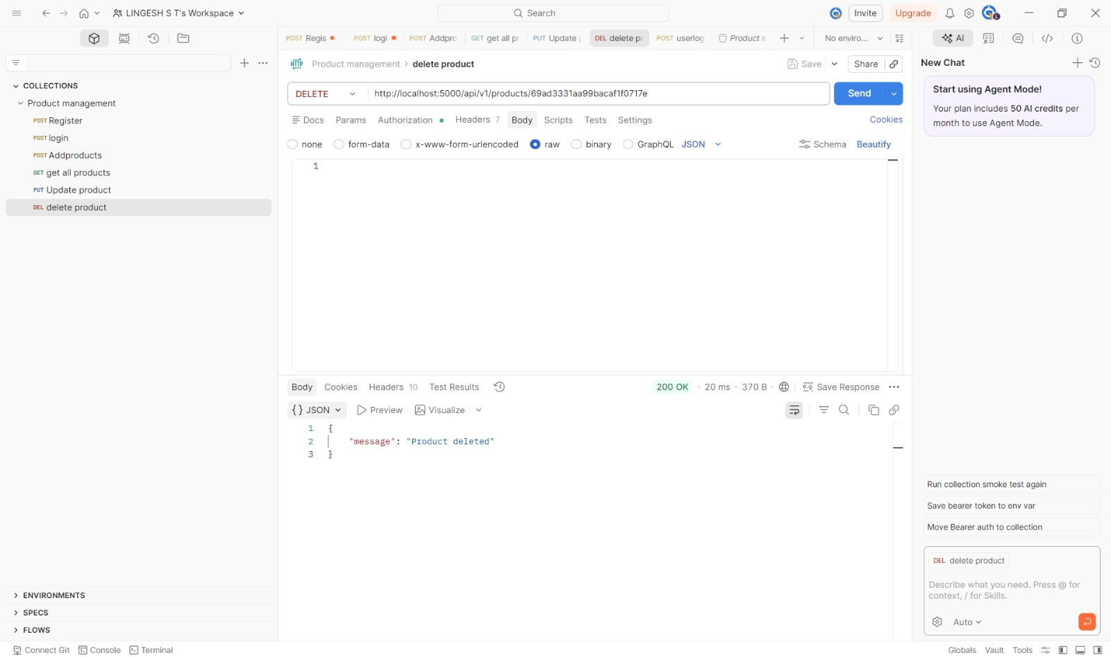

10. Future Enhancements
• Develop a frontend interface using React or Next.js.
• Add role-based access control for administrators.
• Implement product image upload feature.
• Add analytics and reporting dashboard.
• Implement notification and alert systems for low stock.
• Deploy the system on cloud platforms such as AWS or Vercel.

11. Conclusion
The Product Inventory Management System demonstrates backend development using Node.js, Express.js, and MongoDB. It implements secure authentication, structured API design, and efficient database management. The system can be extended with additional features and a frontend interface to become a complete full-stack inventory management solution.

